ASSIGNMENT

# 5TH FEBRUARY

Q1: Explain Class and Object with respect to Object-Oriented Programming. Give a suitable example.

ANS 1 : Class is a blueprint or a template for creating objects. It defines a set of attributes (fields) and methods (functions) that an object of that class can have. Classes can be used to define objects of similar characteristics.

Object is an instance of a class. It has the same attributes and methods as defined in the class, but with different values. An object is a unique entity, with its own state and behavior.

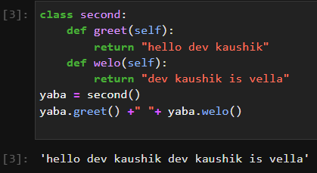

Q2: Name the four pillars of OOPs.

ANS: These four pillars are Inheritance, Polymorphism, Encapsulation and Abstraction.

Q3: Explain why the __init__() function is used. Give a suitable example.

ANS: The __init__ method is a special method in Python classes, commonly referred to as the "constructor". It is automatically called when an object of the class is created, and it allows the programmer to set the initial state of the object.

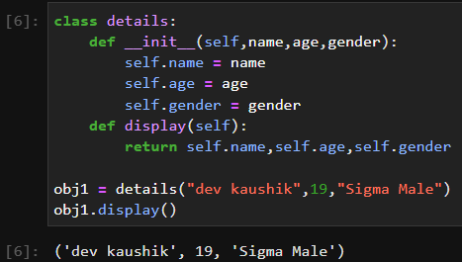

Q4: Why self is used in OOPs?

ANS: n object-oriented programming, the self keyword is used to refer to the current instance of a class. It is used inside a class method to refer to the attributes and methods of the object on which the method is being called.

Q5: What is inheritance? Give an example for each type of inheritance.

ANS : Inheritance is a mechanism in object-oriented programming that allows you to create a new class (known as a derived class) based on an existing class (known as the base class).

There are several types of inheritance in object-oriented programming, including:

Single inheritance: In this type of inheritance, a derived class is created from a single base class.

Multiple inheritance: In this type of inheritance, a derived class is created from multiple base classes

Multi-level inheritance: In this type of inheritance, a class can inherit from another derived class

Hierarchical inheritance: In this type of inheritance, multiple derived classes are created from a single base class.

